Monthly Report of February 2017

Various programs gave colour and vigor to month of February. We had different trainings; visiting new villages and forming new groups, study tour with women, supplementary classes, computer classes etc. We also had the painful experience of government group hijacking our two groups. They are looking for formed groups and promise many things. These all false offering but women fall into it. In the midst of all these life moves on with hope.
Leadership Training:
Knowing the needs of the group we arranged this training. Sometimes the leaders find difficult to bring the women together due to disparity in opinion and thinking. We also have new group in this village. Through examples and stories we explained to them the importance also different types of leadership. We asked them their experience of being a leader in the group also how they co-operate with the leader. Women shared their observation and experiences.
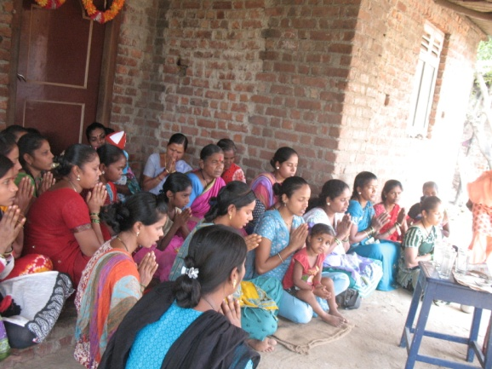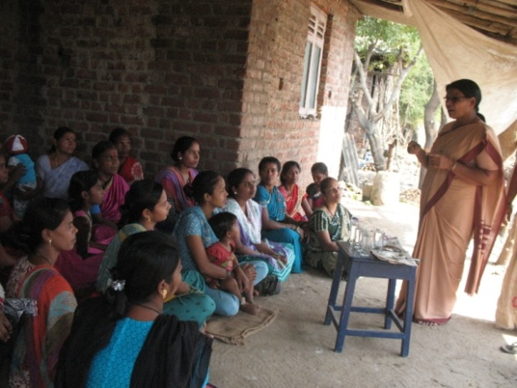
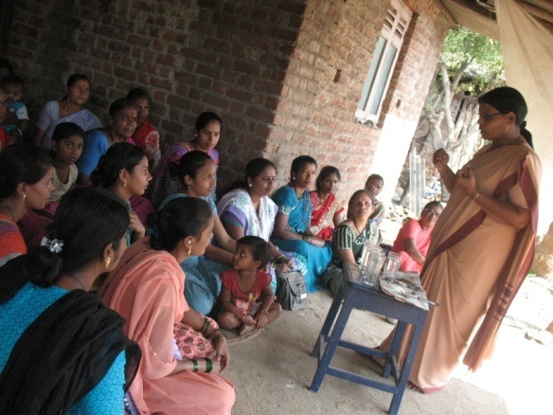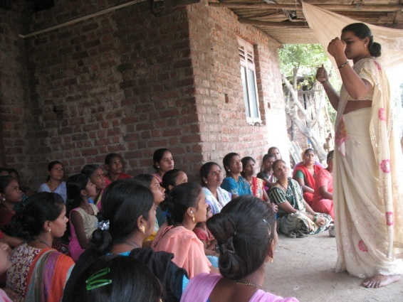

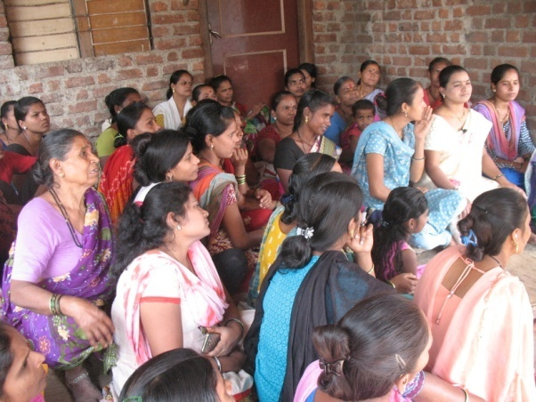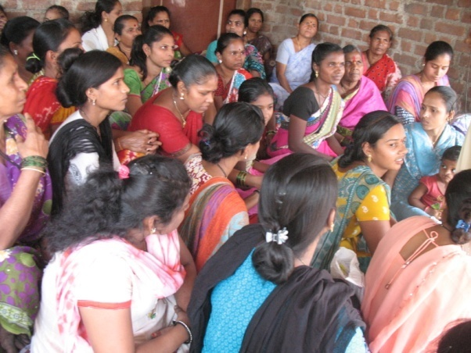

Meeting with New groups:
This is Tokpada and we have two groups here. Through the influence of our supplementary teacher and our visit in the village, we managed to gather few women who are interested to form the group. We had the meeting in an open ground where we found little shade. Since other groups are going on well these women were convinced of to start the group. Tokpada being a big village we feel more women will come forward to form the group.

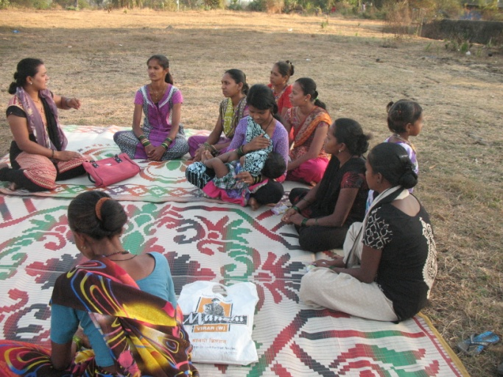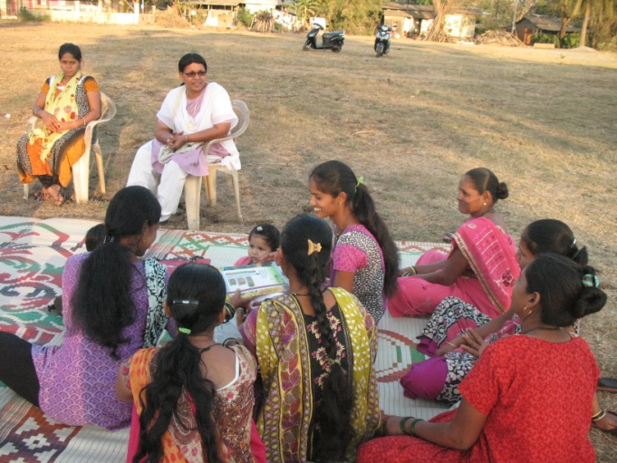

Supplementary Classes:
Among the five supplementary centers four will be closing by February. Two centers will carry on till the end of March because the parents requested us to help the students during their exam time. Few students are regular for the classes while few try to skip it. There is a big problem of water scarcity in this village and children goes to bring the water thus to help their mothers in the house hold work. Therefore few children come late for the classes. We told the children that unless you struggle, you cannot reach your goal. Unless you take pains, you can never taste the desired fruits. Hence work hard.

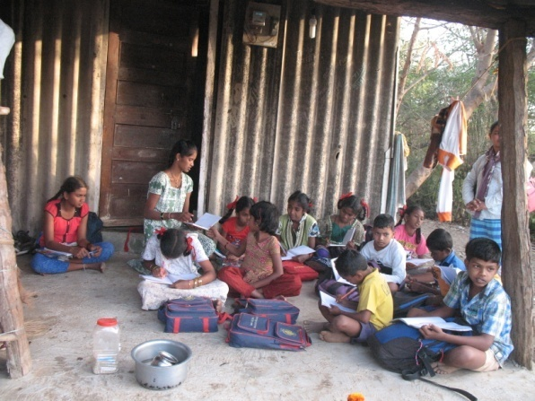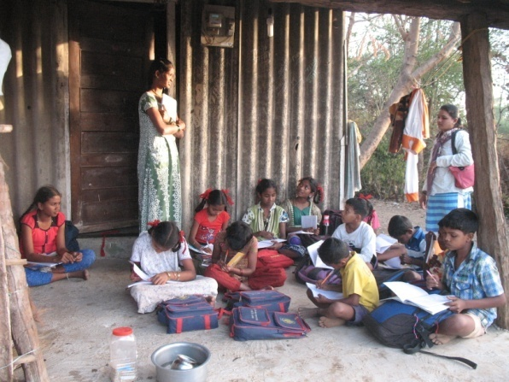

Study Tour:-
In our life there is so much to learn and not just at school. We arranged a study tour for our SHG women to visit important places at Mumbai. It was like full of insightful and informative. They got abundant opportunities to see many things. They experienced a new culture, language and surroundings. They thoroughly enjoyed the day including the travel. It was really a memorable experience for them and for us.

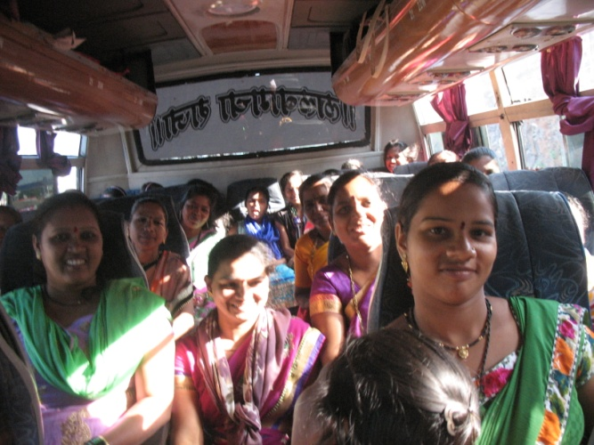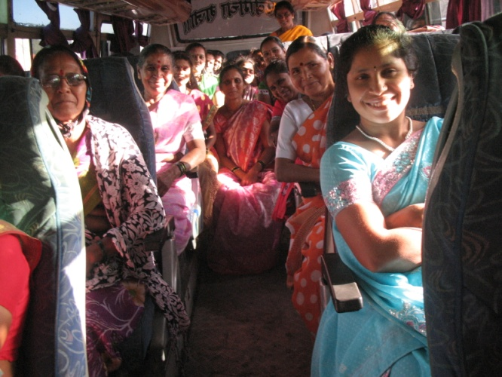
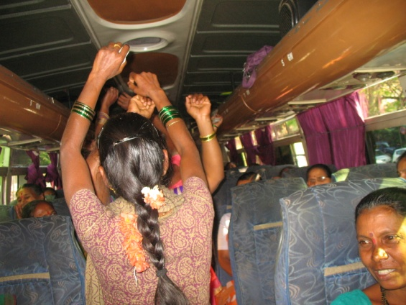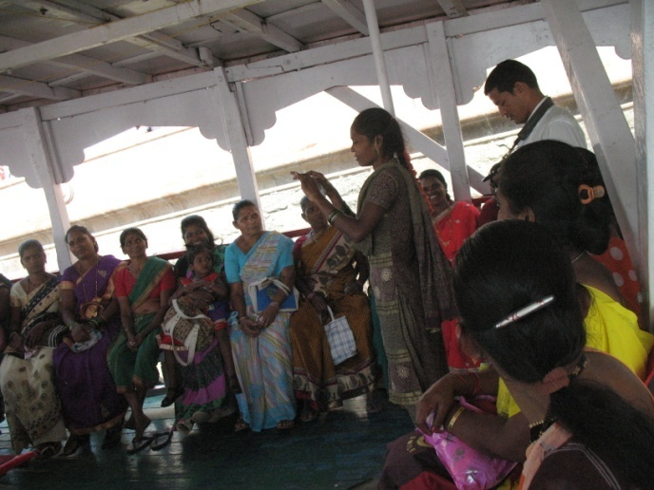
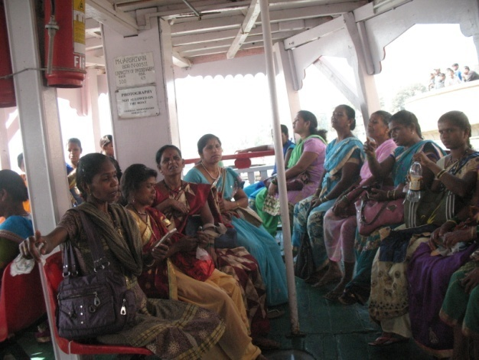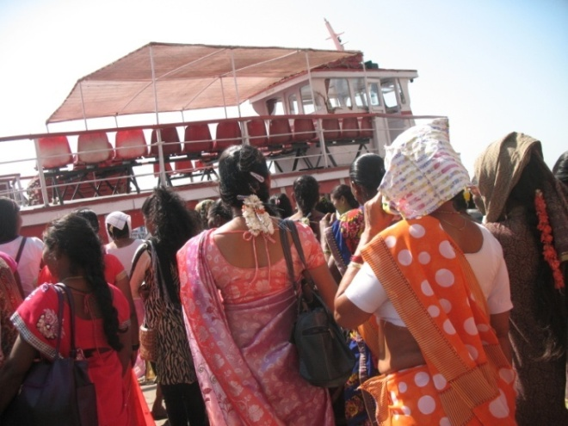

Street play training:
Street play is theater media as a means of raising awarness on social issues prevelent in the society, like cild labour, womens empowerment etc. It is a form of thetrical performance and presentation in out door public spaces.
We discussed about street play with women and with their consent we called the resource person to train them. The first day all were very shy to perform but when they got the tast of it they were super in their actions and they forgot about their shyness. The trainer took the issue of ordinary woman’s place in society and the difficulties which she goes through. It was very much connected to their daily life too and they came out very well.
We are planning to perform it in another villages also during the womens day celebration here. They realized that all of them are blessed with different talents and only thing needed is to say yes to it. This one group coming forward like this inspire many other women to come out also to the awarness of some of the social issues.
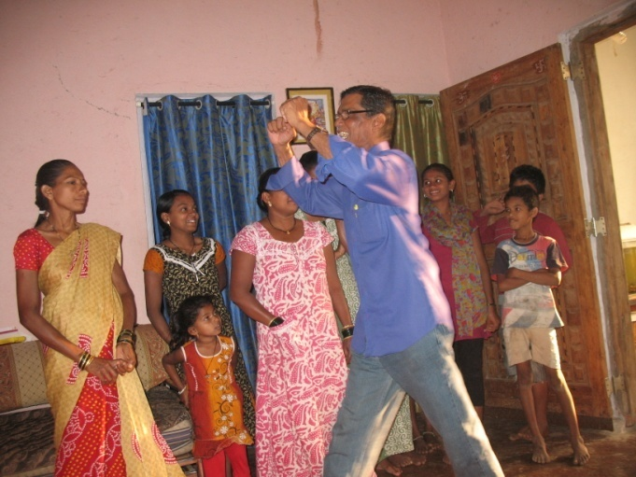

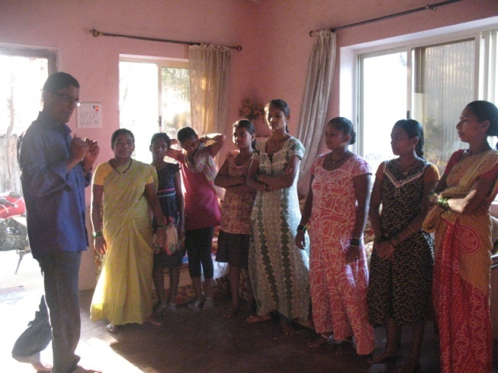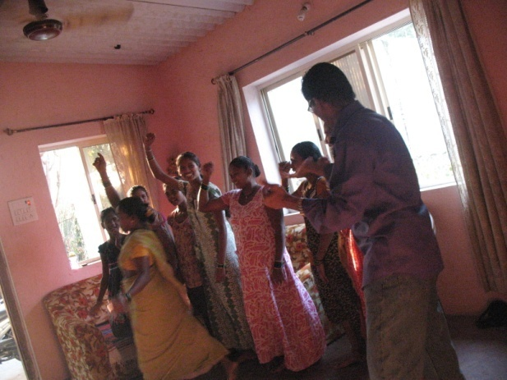
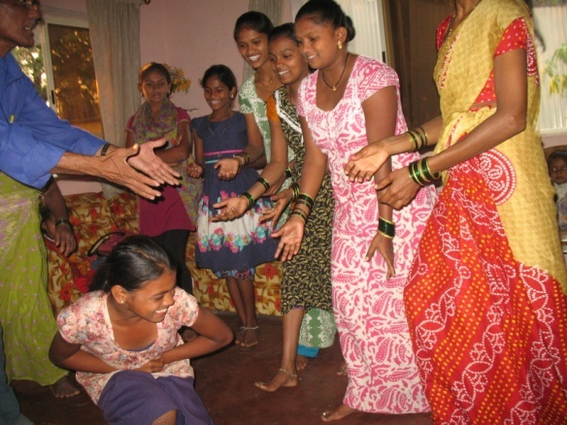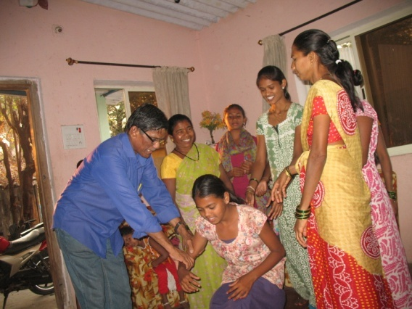

Through all these activities we want to make our women and children to dream for a better society also to celebrate all the opportunities which enable them, not to lose the hope of a better world with greater possibilities.
Sr. Alphy
Jivhalla Assumption Social Centre
Rajodi

