JANKALYAN BOARDING REPORT
Firstly, I would like to express my heartfelt thanks to you for all the help and support you have once again been extending to us, right from the beginning of the year.
This year we have had 47 admissions to the Boarding.
School reopened on the 16th of June. Students of classes 4th to 7th attend Municipal School No. 1. Students of classes 8th to 10th attend the school AdarshVidyalaya.
The following tasks/activities were carried out in June – July 2014:
- Books were given standard wise to each student according to their school requirement.
- Stationery items i.e. compass box, pencil, sharpener, eraser, sketch pens & crayons etc.were given to each child.
- Uniforms were given to the children.
- Medical care was provided as required.
- Children went on a short hike in the hills near the boarding one Sunday.
- In-house Supplementary classes are conducted every day for all the children from 8 AM to 10 AM. The children have a weekly test so that their academic progress can be evaluated.
- The children have half an hour of exercise followed by meditation every morning.
- The children enthusiastically play football, handball & carom in their recreation time.
We have conducted interviews with 3 of our ex-students who have now started working. I would like to share their feelings and the views they have expressed with you. Below is the translated text of what they have expressed:
Interviews of Ex-Students
- Darshan Shivaji Jangam

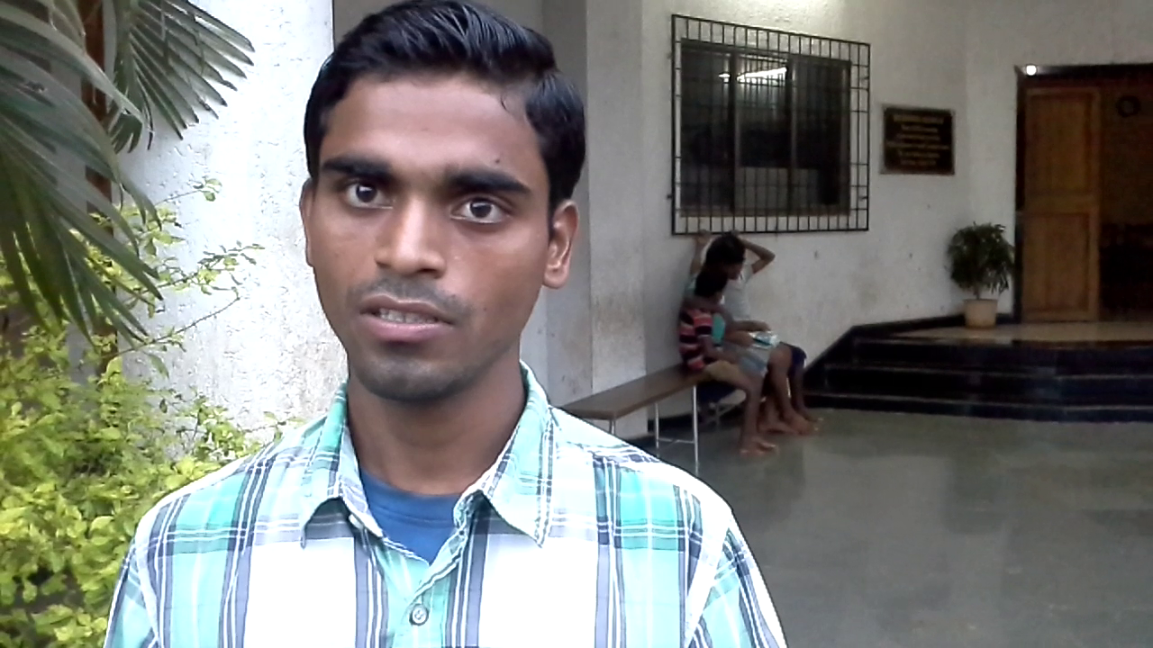

“My name is Darshan Shivaji Jangam. My parents expired when I was small and I was being brought up by my aunt. She admitted me to this boarding. I was in class 1 when I came in. I then completed my education from class 1 to class 10 here. Just as parents love their children, I received the same love here in this boarding. I have stayed here treating it as my own home. All the financial expenses of my studies were also borne by the boarding. After 10th, I was also able to complete the I.T.I.(technical) course successfully in the chemical trade. I am now employed in a new firm with a good post. Thank you.”

- Ganesh Tribhuvan
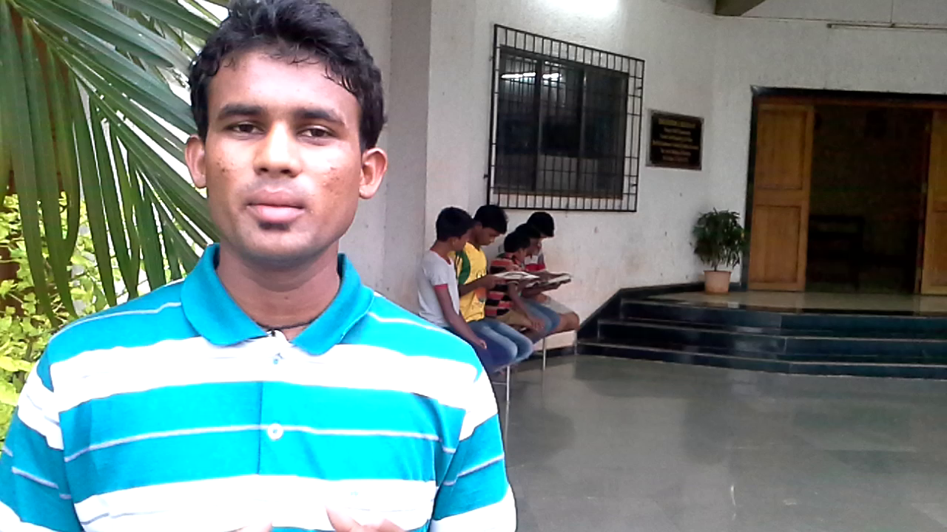
“My name is Ganesh Tribhuvan. Our financial condition at home was very poor with not enough money for food & expenses. We came to know that the Jankalyan Trust in Mahad helps backward class children. Hence, I came here to the boarding with my two brothers. This institution shows concern and takes very good care of its children just like a mother who cares for her children. We are encouraged to make our own career choices and no burdens are imposed. Father says, “Only study well and I am behind you to support you always.” I am here right from the 3rd grade. I successfully completed my primary and secondary education (10th grade) and junior college (12th grade). I then wanted to do a course in Hotel Management. Father encouraged and supported me in this. After completing the course I am now working with a well known hotel Residency Club in Pune. I am also now trying to go abroad. In this way Jankalyan Trust is an institution that helps everyone.”

- Abhay Sodekhade

“My name is Abhay Sodekhade. I came to the Jankalyan Boarding in 2013 and have now completed my 10th grade. While studying here, the staff of Jankalyan provided me with proper guidance for success. This guidance is done with lot of concern and care for all the children. An environment conducive to education is provided and because of this I got immersed in my studies. Hence, as I leave the Boarding, I express my gratitude to the Jankalyan Parivar. Thank you.”

Fr. Barthol Machado
Director
Jankalyan Trust Mahad.

