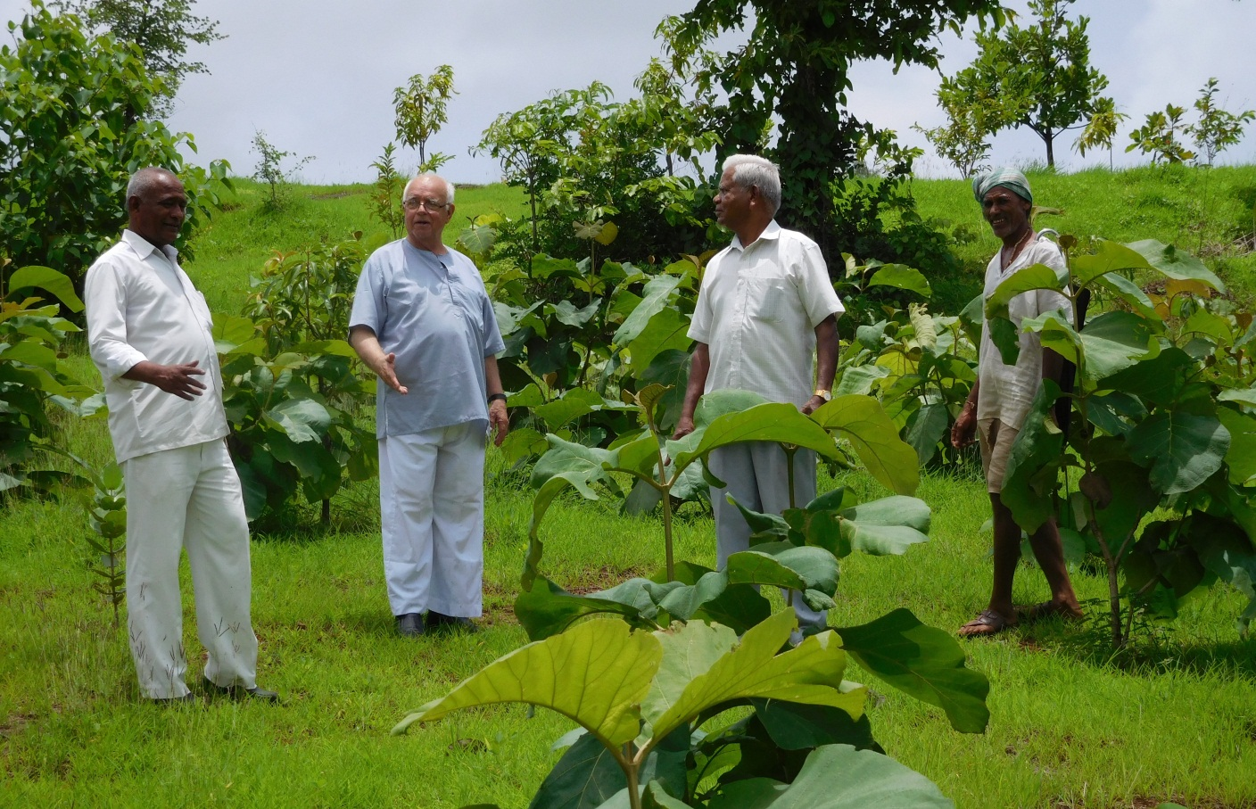
the legend of Perico keeps living on
far from the world where once he was born
on hills and in valleys, over fields and through streams
Perico reached out in quest of his dreams
crafting creation with passionate care
contouring the hillslopes and greening the bare
there are those who recall his answers to need
his tending the growth of the littlest seed
he worked for a change in the world that we know
that nature would flourish and the poor get to grow
where the fist of the mighty would open to give
and all have the means to prosper and live
what matter remembered or lost in the mists
may his striving be noted in heaven’s true lists
Perico returned to the land of his birth
his legend still roaming this realm of God’s earth

