Monthly report of January 2017
There is no greater creativity in life or leadership than the ability to touch each moment that you are living with the beauty of living it by your heart, to give back to life the fullness that it has had the generosity to give to you. This is the experience month of December. We were fully busy with organizing and networking with others for a cause. The various activities which are explained below helped us to become part and parcel of the people by being with them also doing something for them.

Cancer Detection Camp at JASC:-
We had already done one medical camp to the women and children in December but still we arranged the Cancer detection camp for the ladies who were not able to attend it in 2015. Through this program we were able to make them aware of this sickness which growing so fast and also explain to them how to detect it in its early stage through symptoms. This was arranged for only fifty women.

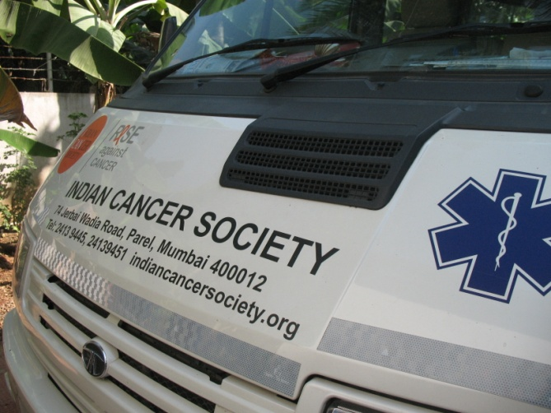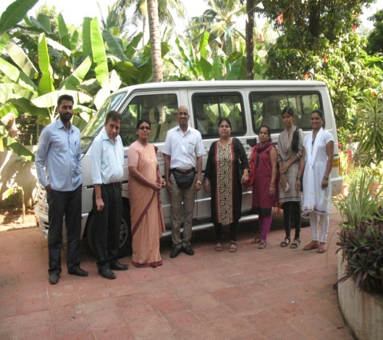

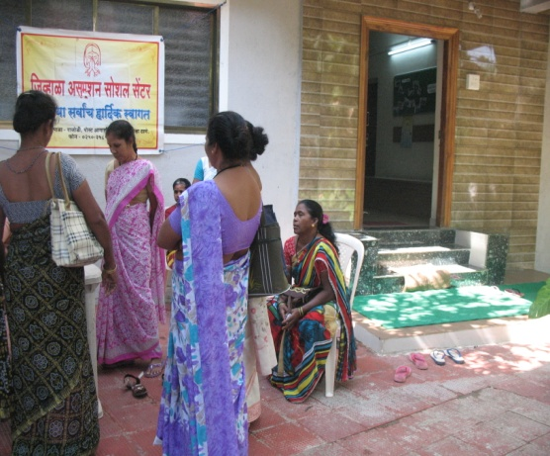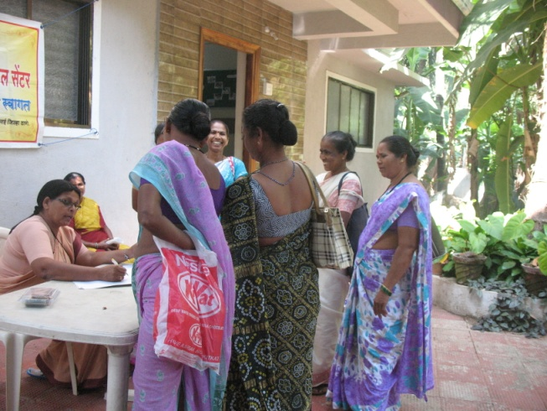
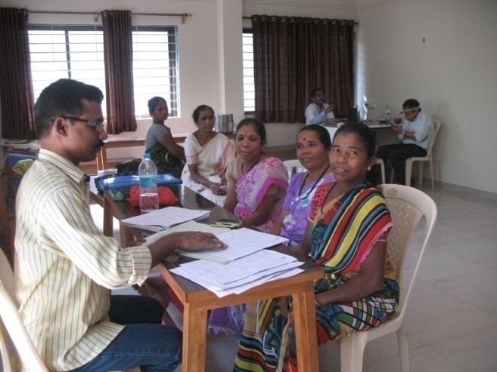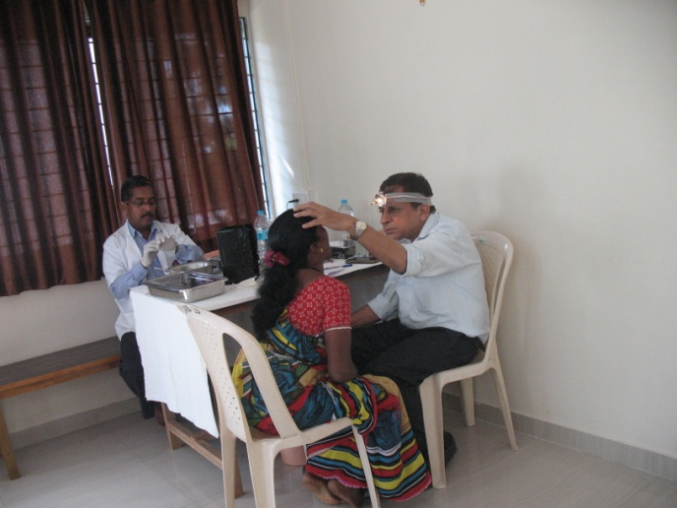
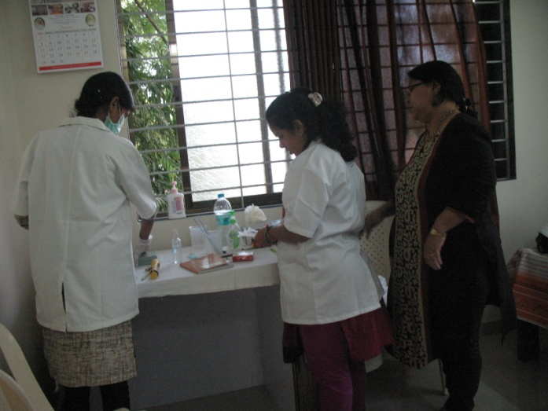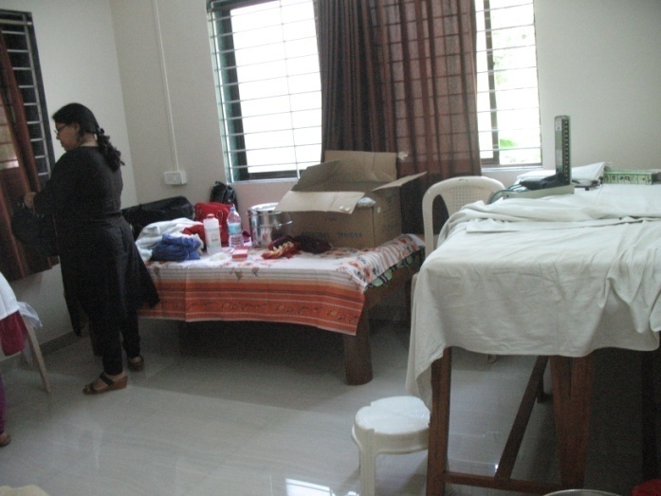
Tailoring Class at JASC:-
The tailoring classes will be getting over by this month because the exams are coming closer and students wants to prepare for the exams in the college. Instead of learning all what in the teachers file. The students selected the items which they want also in demand in the market and they completed it.
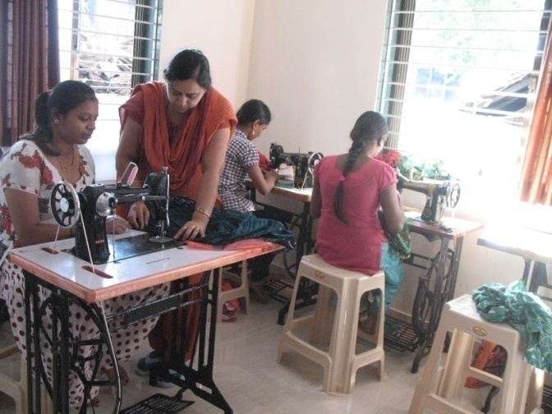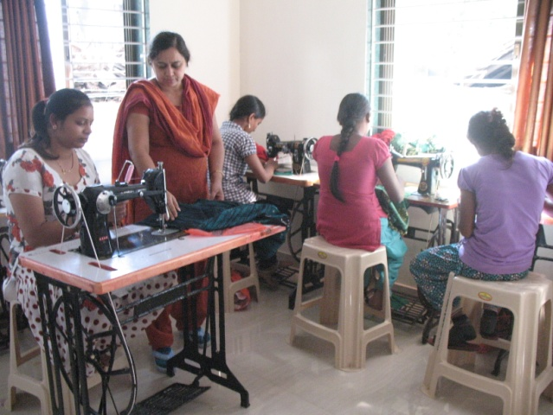

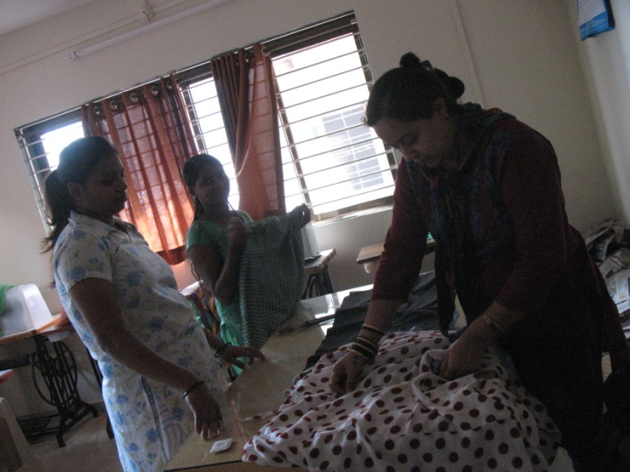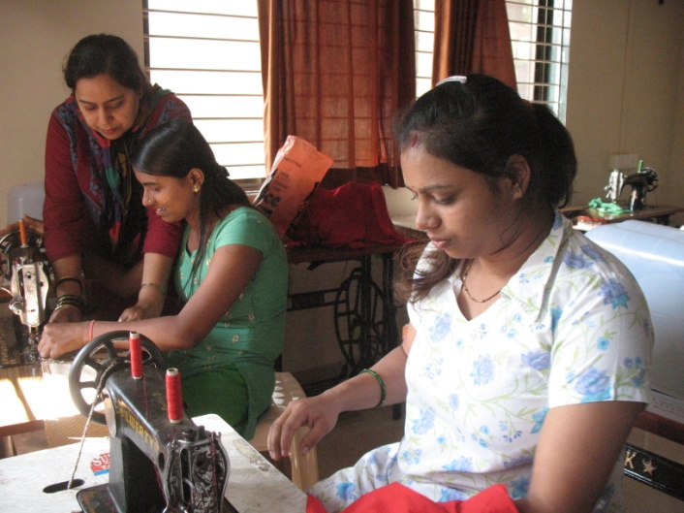

Beautician Class:-
Beauticians are in high demand in these days. The students are already started getting the customers before they completed the classes.
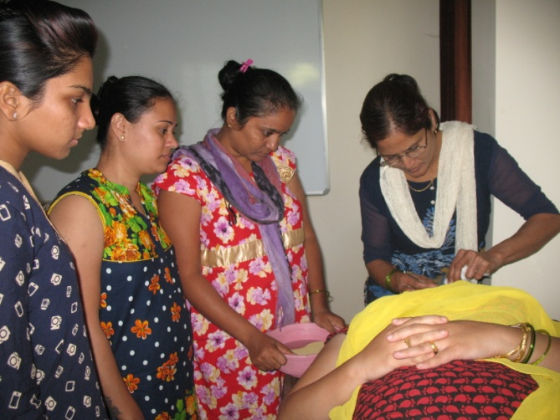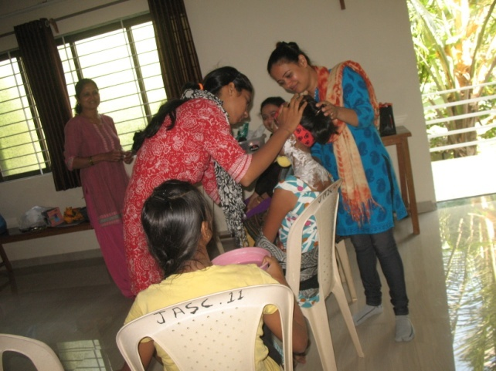
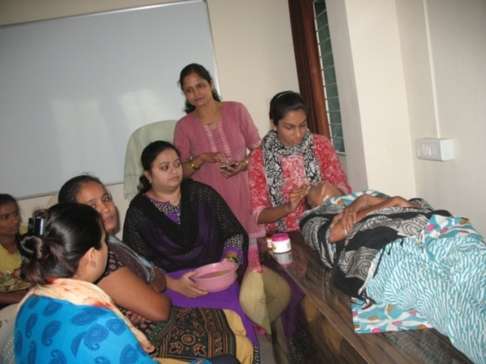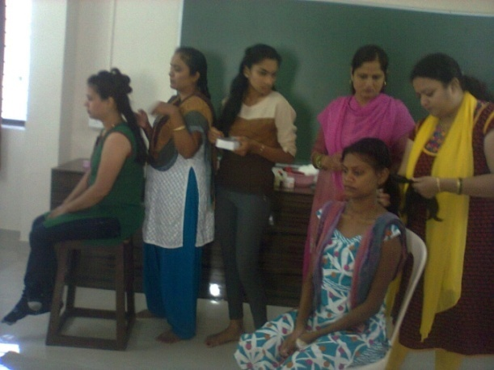
Computer Classes:-
Many students are coming for the classes and profiting from it. In the school they do not get much time also not taught properly. Here sr. Geeta is taking lot of effort to teach them also helping them to do their projects in the computer.

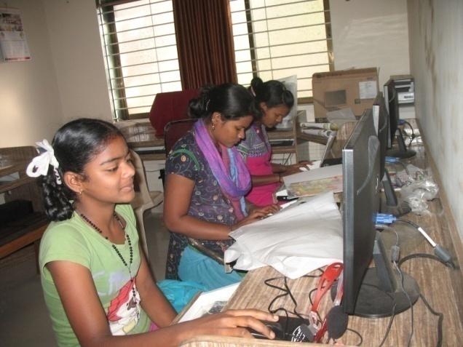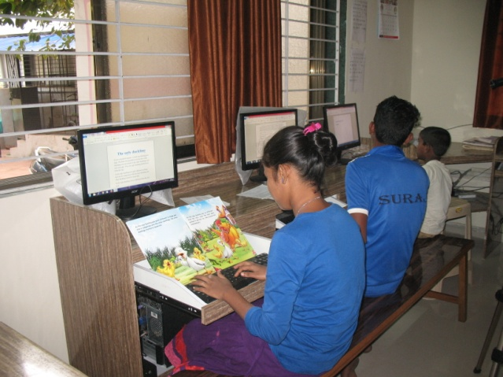

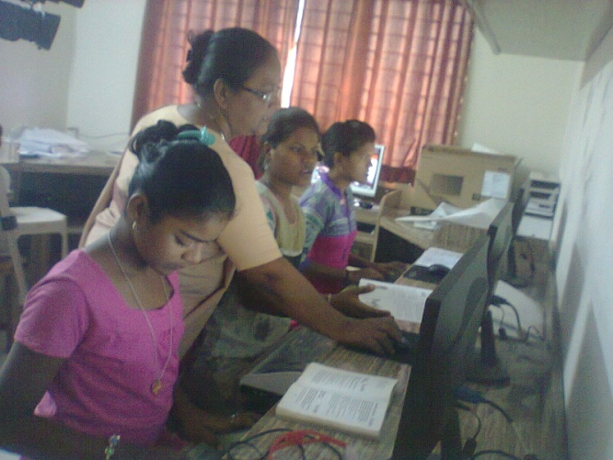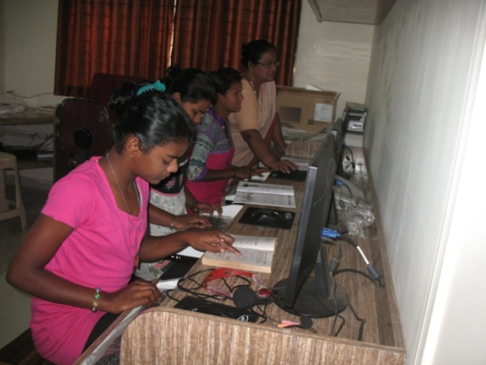

Meeting of the old and new SHG:-
We have two existing SHG’s in this village and women for two more groups gathered to know about SHG. Actually our Supplementary teacher in this village too took the initiative to form the group because she herself wanted to be a member in the group. Having more groups in a village is a real advantage for us to take classes or training. The new one’s observed the meeting of the existing ones – like paying the installments also applying for loan. Then we took the meeting of the new comers and explained to them about SHG and its benefits, rules and regulations. We also fix the date of their meeting too.
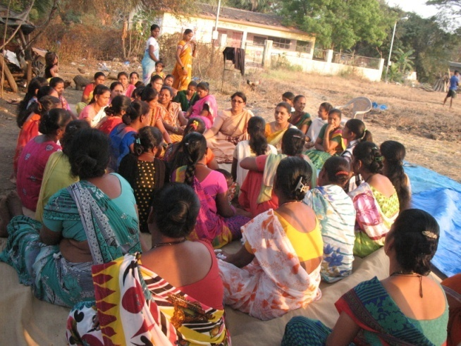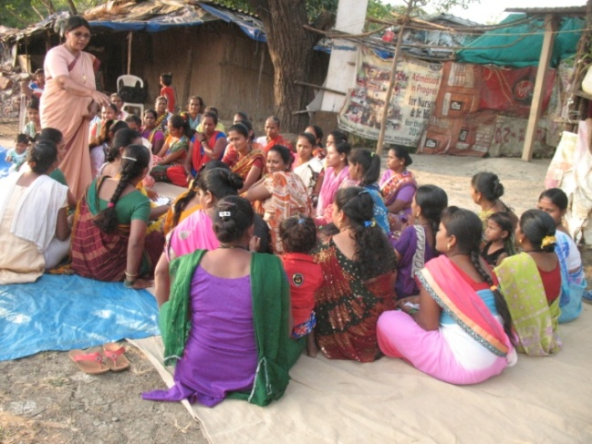
Haldhi Kunkum Program:-

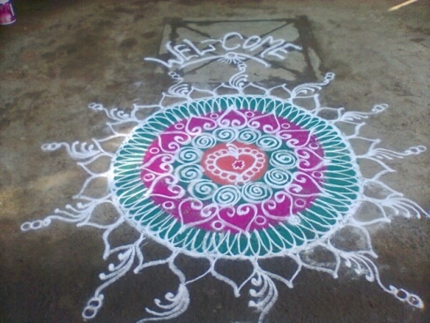
This is a custom in the Maharashtra villages to have the celebration of Haldi kunkumkafter the 14th of January. Women came together and they celebrated it. We too took part in it.

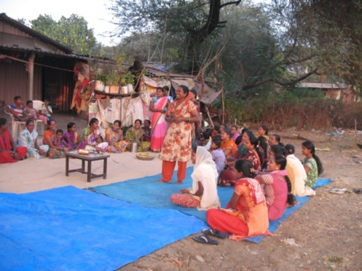
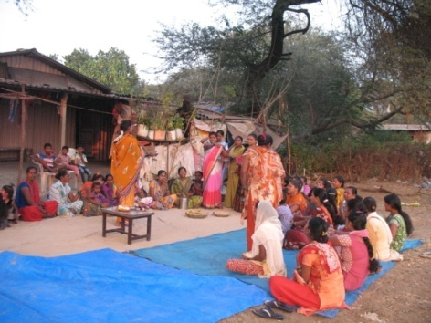

Supplementary Centers:-

Our supplementary centers are going on well. Since students go to school in the morning the classes in the center are in the evening. During the class we encouraged them to do the home work first so that they can ask the doubts to the teacher. One thing we noticed that even in the least developed village where we work, children do not roam without going to the school. Parents are aware of the importance of education and they appreciate the classes we run in their village.

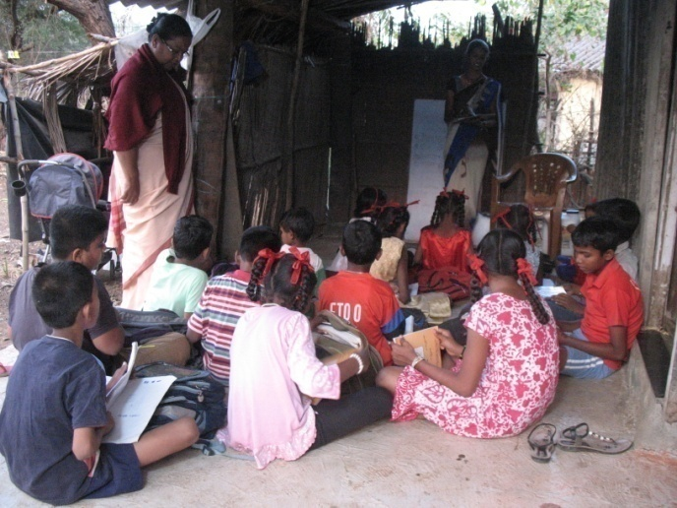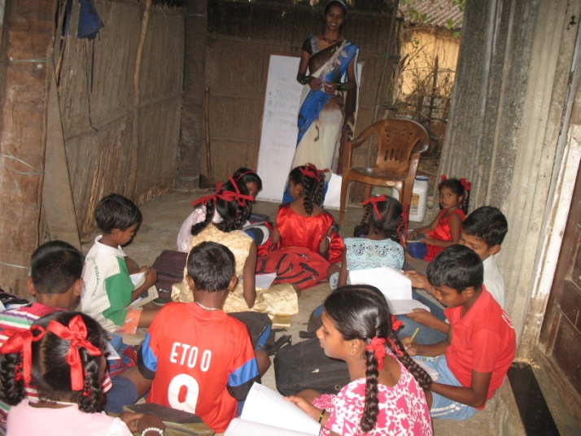

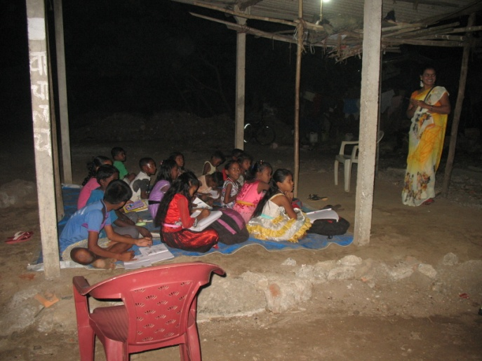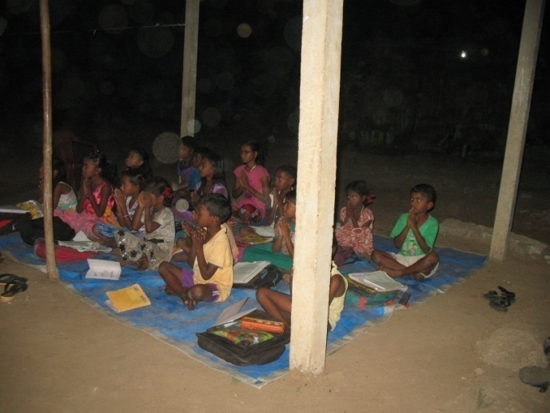
Vadapav center in a remote village:-
Finally our ladies got a little place in the village with the permission of Panjayat and they built a vadpav shop. This shop is very famous over there and children and elders visit them in the evening. Women open the shop only in the evening after they come back from the work. They bought all the equipment like gas cylinder, vessels etc. their own also deposit money every month in the bank. Whenever we have the training in the village we give order to this group to encourage them.

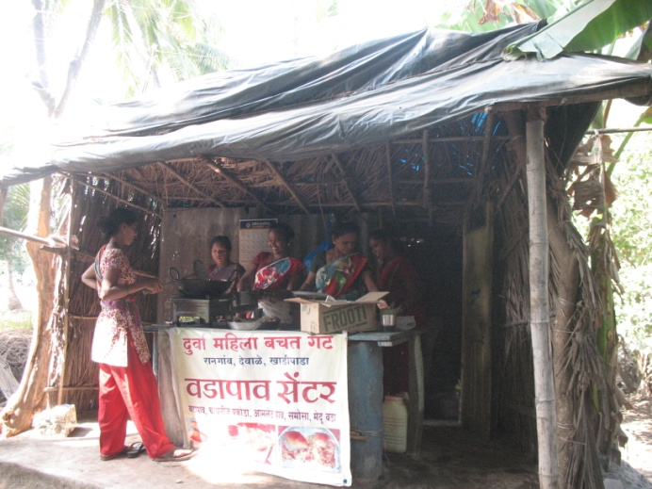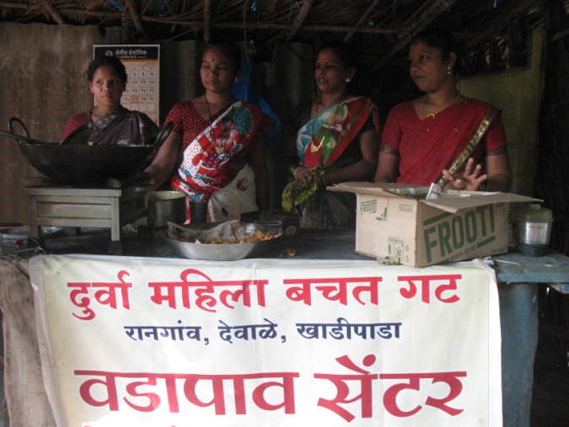

Opening the Account in Canara Bank:-
One more new group has started their account in the Canara Bank. There are many advantages in this bank compare to other banks. Four members of this group are separated from another group, and other four are from an existing group which is going to close soon and others are new members. These women shared with us that it is difficult for them to live without SHG because it supports them in all the level.
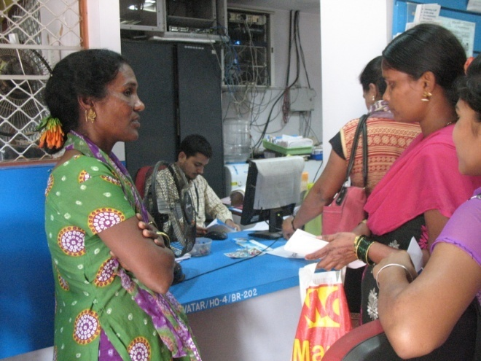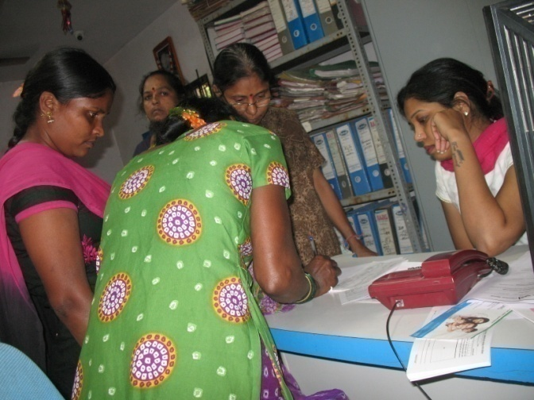

Certificate giving ceremony:-
Both tailoring and Beauticians completed their classes successfully and obtained certificates. We had a short program to honor and encourage the teachers and students. Our parish priest Fr. Joe Dmello gave an inspiring message and made the program more meaningful. Everybody enjoyed the program well.
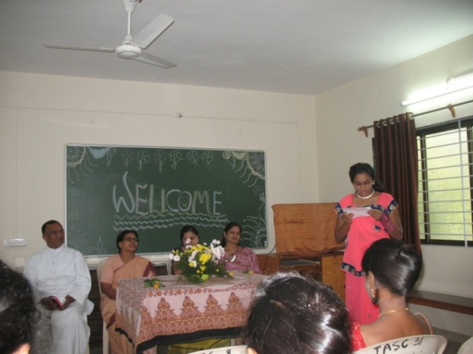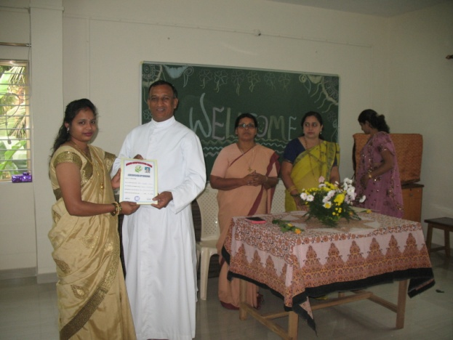
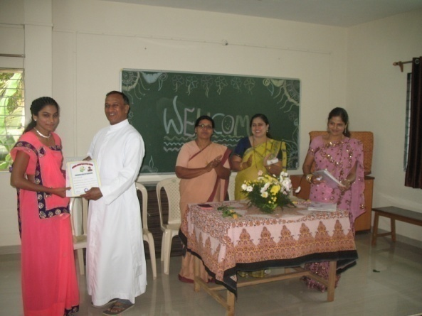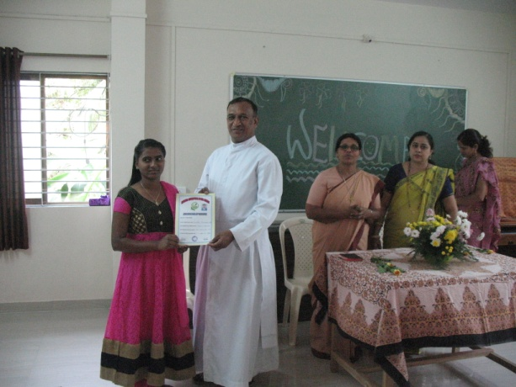

Exhibition of the stitched dresses:-
Tailoring student’s exhibited the dresses which they stitched and everybody congratulated them.

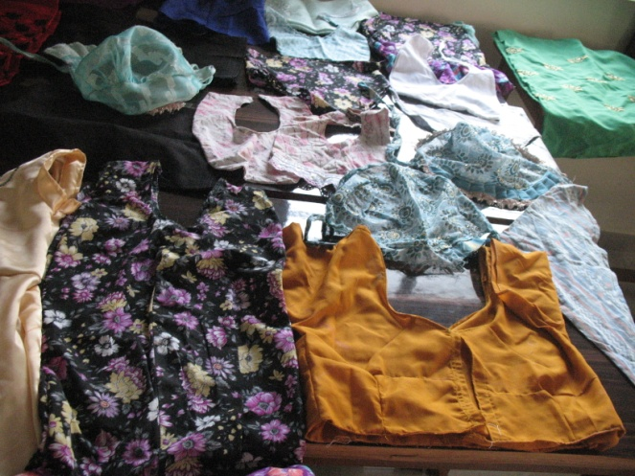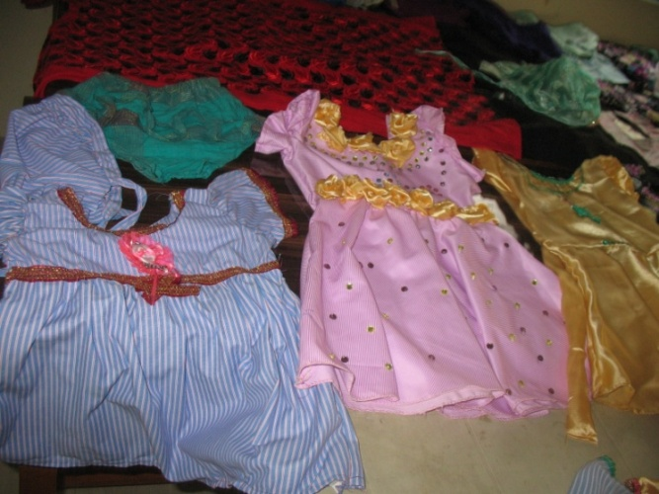
Republic program in different Supplementary centers:-
We organized various programs on Republic Day in our supplementary centers. Teachers prepared the students with speeches and cultural program. Sr. Alphy and Mrs. Reshma Rakesh gave message to the students. Children were so enthusiastic to perform the cultural items. Since there wasn’t much place in the class room, teachers arranged the program outside the classroom. We congratulated the children also encouraged them to come out from their shyness.
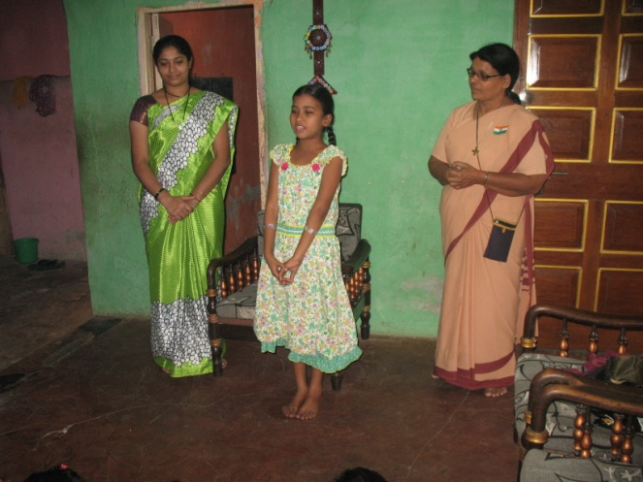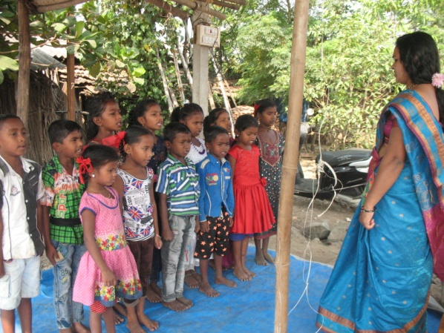
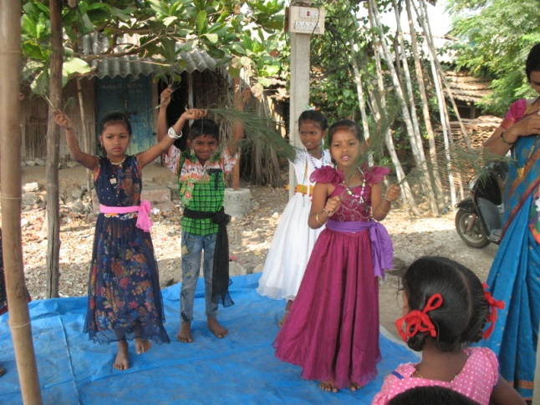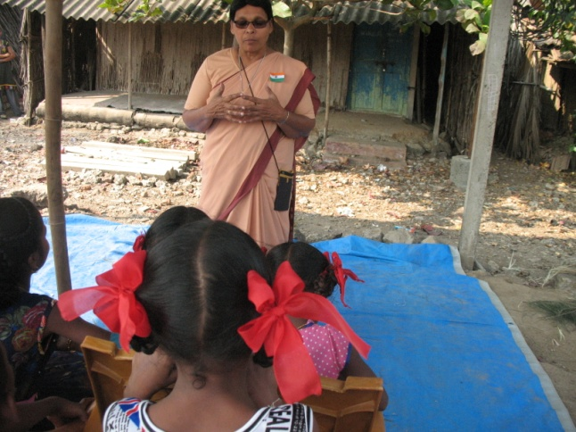

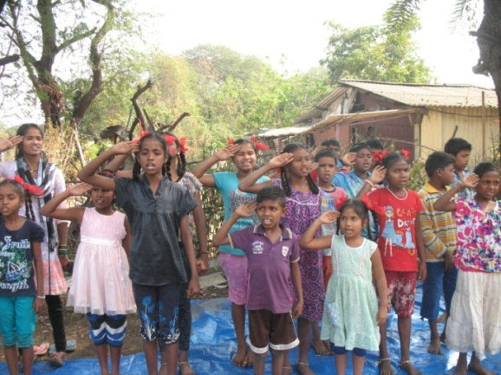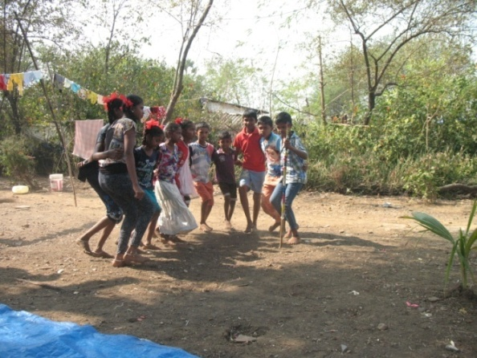

Kitchen Garden by an SHG woman: - She has no land of her own but she managed to have a vegetable garden next to her home and getting vegetables from the garden.
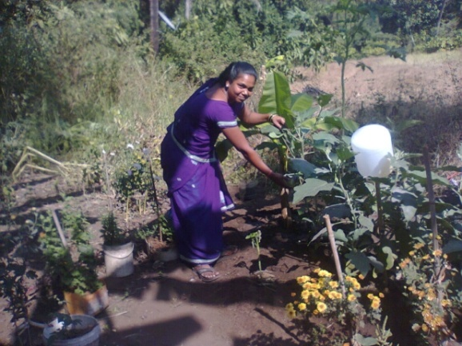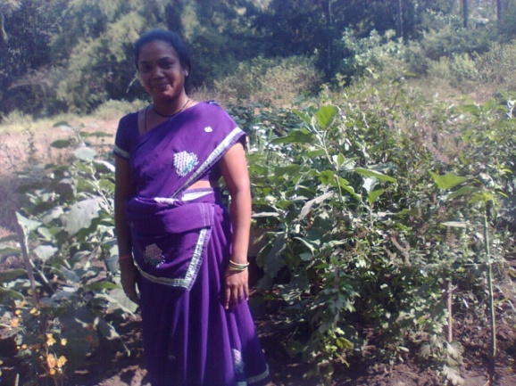
Beach Cleaning by NGO’s:-
After having discussions and meetings together, five NGO’s came together to launch a program called ‘clean the beach’. The beach we decided upon was Rajodi beach. From JASC Pinky and me took part in it. About two hours we worked to clean the Rajodi beach. This is also to give awareness to the people to keep clean the beach also not to through the rubbish to the sea.
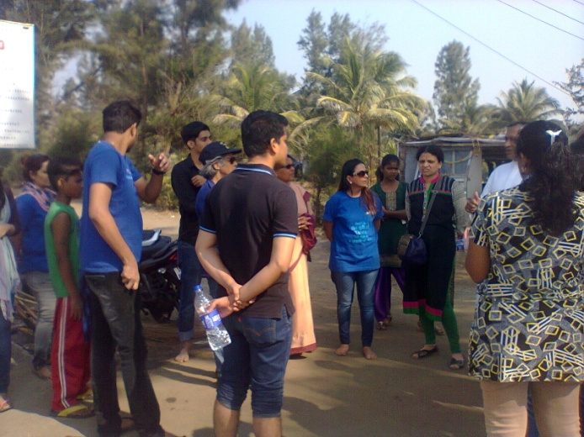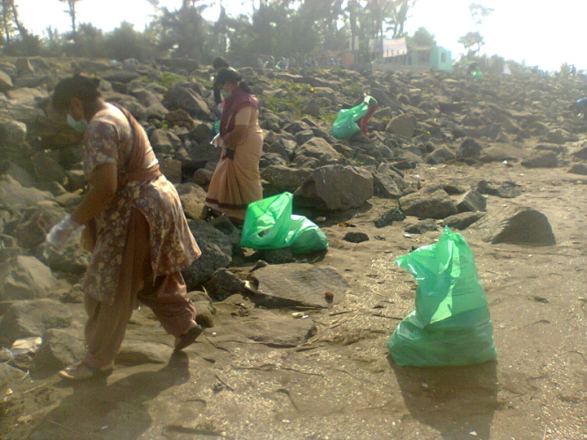
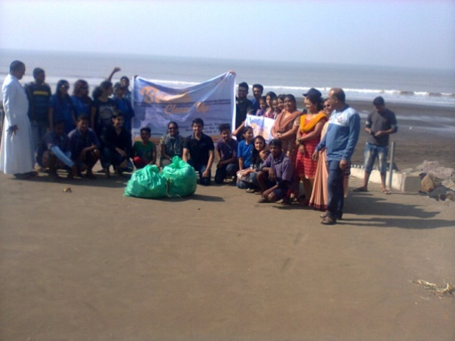
Joining with the Vasai people for a cause:-
Government is planning to stop the sixty years of old Transport buses in Vasai area and instead they are promising the municipality buses. People are not happy with the municipal buses because its service is very poor. Government is also planning to take out the Vasai green belt and change into industrial area. We along with people conducted different awareness sessions about it in Rajodi and nearby villages and on 26th afternoon we along with people went to the Tahasildhar’s office to submit a memorandum concerning above mentioned topics.

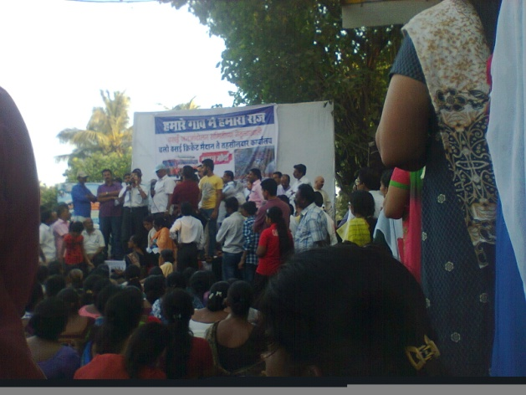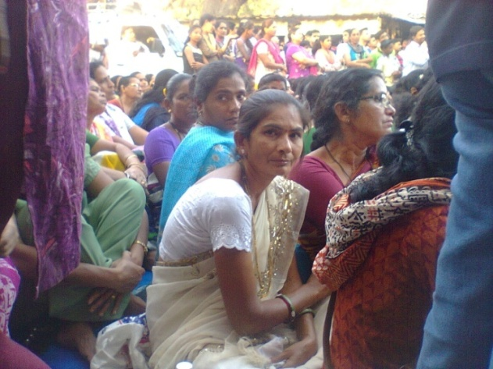

It had been an enriching experience for us to be with people and their problems as well face the challenges of the time. We realized that if we really need to do something we will find the way.
Sr. Alphy
Jivhalla Assumption Social Center
Rajodi

